**ASSIGNMENT # 1**

**Subject COMPUTER NETWORKING**

**Topic**



**Submitted by: Zulnorain Ahmed**

**Submitted to: Sir Bakhtawar**

**Program: BS (cs)**

**Registration #: 2121-124003**

**Date of Submission: 26/01/2025**

**DEPARTMENT OF BS (CS)**

**PRE STON UNIVERSITY KOHAT**

**1. Definition of Unicast Communication**

Unicast communication refers to a one-to-one communication model in networking where data is transmitted from a single sender to a single receiver. In this model, the sender explicitly targets a unique destination address, ensuring that only the intended recipient processes the data. This is the most common form of communication in IP networks.

**2. How Unicast Communication Works**

In a unicast network:

1. The sender generates data packets and embeds the receiver's unique IP address in the destination field of the packet header.
2. The network routes the packets based on the destination IP address using routing tables and protocols.
3. The receiver identifies and processes the packets addressed to it.

Unicast communication typically operates over protocols like TCP or UDP, ensuring data delivery based on the application’s requirements (e.g., reliable or fast).

**3. Unicast Protocols**

**1. Transmission Control Protocol (TCP):**

* **Description:** A connection-oriented protocol ensuring reliable data transfer between sender and receiver.
* **Use Case:** File transfer, web browsing, and email services.

**2. User Datagram Protocol (UDP):**

* **Description:** A connectionless protocol offering fast but unreliable data transmission.
* **Use Case:** Video streaming, online gaming, and voice-over-IP (VoIP).

**3. Hypertext Transfer Protocol (HTTP):**

* **Description:** A protocol used for transferring hypertext (web pages) over the internet.
* **Use Case:** Accessing websites and APIs.

**4. Advantages and Disadvantages of Unicast Communication**

**Advantages:**

1. **Reliability:** Ensures accurate data delivery when using protocols like TCP.
2. **Security:** Data is sent directly to the intended recipient, reducing exposure to unauthorized entities.
3. **Flexibility:** Supports diverse applications, from simple file transfers to complex web services.

**Disadvantages:**

1. **Scalability Issues:** Inefficient for broadcasting data to multiple recipients, as separate streams are required for each.
2. **Bandwidth Consumption:** High bandwidth usage when sending the same data to multiple users.

**5. Real-World Examples of Unicast Protocol Usage**

1. **Email Communication (SMTP/IMAP/POP3):** Sending and receiving emails between users relies on unicast.
2. **Web Browsing (HTTP/HTTPS):** When accessing a website, data is exchanged between your device and the web server via unicast.
3. **Video Streaming (Netflix, YouTube):** Content is streamed from a server to a specific user over unicast protocols.

**Definition of Multicast Communication**

Multicast is a one-to-many communication where data is transmitted from a single sender to multiple specific receivers simultaneously. It conserves bandwidth compared to unicast.

**2. How It Differs from Unicast**

Unlike unicast’s one-to-one delivery, multicast sends data to multiple recipients in a single transmission, reducing redundancy.

**3. Multicast Protocols**

1. **IGMP:** Manages multicast group memberships.
2. **PIM:** Routes multicast traffic efficiently across networks.
3. **RTP:** Supports real-time data transfer, like audio and video.

**4. Benefits of Multicast Routing**

* Saves bandwidth by sending a single stream to multiple receivers.
* Efficient for real-time applications like video conferencing.

**5. Real-World Examples**

* **Video Streaming:** IPTV and live broadcasts.
* **Financial Data:** Real-time stock market updates.
* **Online Training:** Webinars and e-learning platforms.

**Packet Tracer Task – Configuring RIP or OSPF with Loopback Addresses**

**Task Overview**

Students will configure RIP or OSPF routing in Packet Tracer, including loopback addresses, to understand how routers manage multiple networks.

**Steps to Complete the Task**

**1. Network Setup:**

* Open Cisco Packet Tracer and create a network with:
  + Three routers.
  + Two PCs connected to different routers.
  + Use Serial and Ethernet connections to link the routers.

**2. Assign IP Addresses:**

* Configure IP addresses for each router’s interfaces.
* Use a /30 subnet mask for WAN links (serial connections).
* Assign IP addresses to PCs (use /24 subnet mask).

**3. Configure Loopback Addresses:**

* Assign a loopback address on each router for testing and stability.
* Example:

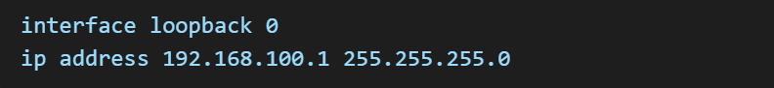

**4. Enable Routing Protocol:**

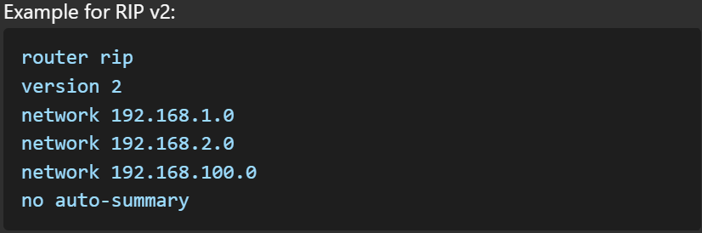

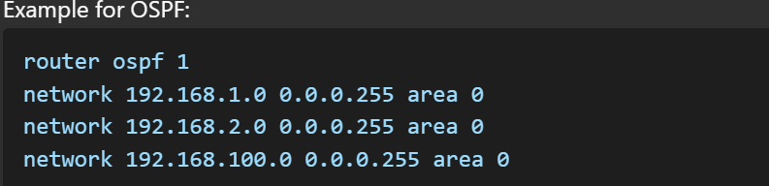

**5. Verify Connectivity:**

* Use the show ip route command to check the routing table.
* Use ping between PCs to ensure connectivity.

**Submission Requirements:**

1. Take screenshots of:
   * Routing table (show ip route).
   * Successful ping results.
   * Network topology in Packet Tracer.